**Project User Guide**

**On**

**“Online Shopping Cart”**



**Aptech Computer Education – MSG-Karachi**

**Submitted By: Guided By**

1. Zohaib khan Sir Amjad

2. Muhammad Shah fahad Teacher,

Aptech-MSG-Karachi

**CERTIFICATE**



**This is to certify that Web Application for**

**Online Shopping Cart has been completed with all functionality by the students of**

**PR-201811E.**

Zohaib khan, Muhammad Shah fahad

**SOFTWARE INTERFACE**

**Login**

**User Name: zohaib (admin) Password(12345),**

**ali(Employee) Password(123),**

**fahad(Customer) Password(123456)**

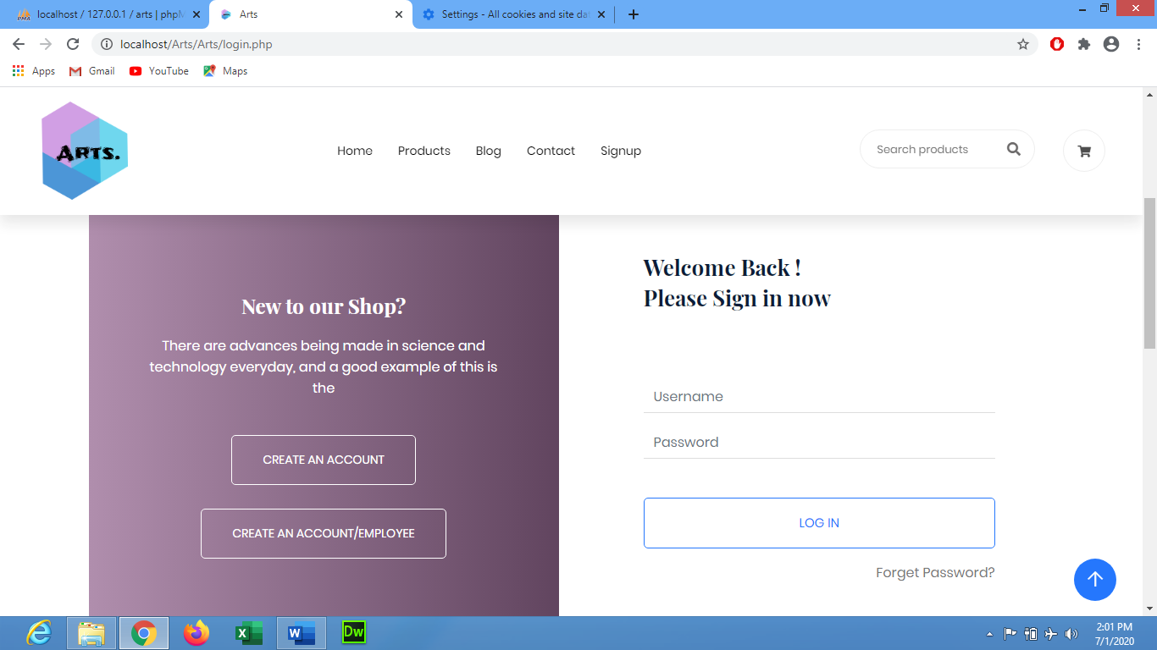

**3**

**2**

**1**

This is login panel, software automatically detect weather it is ADMIN, Employee or Customer.

**ADMIN PANEL**

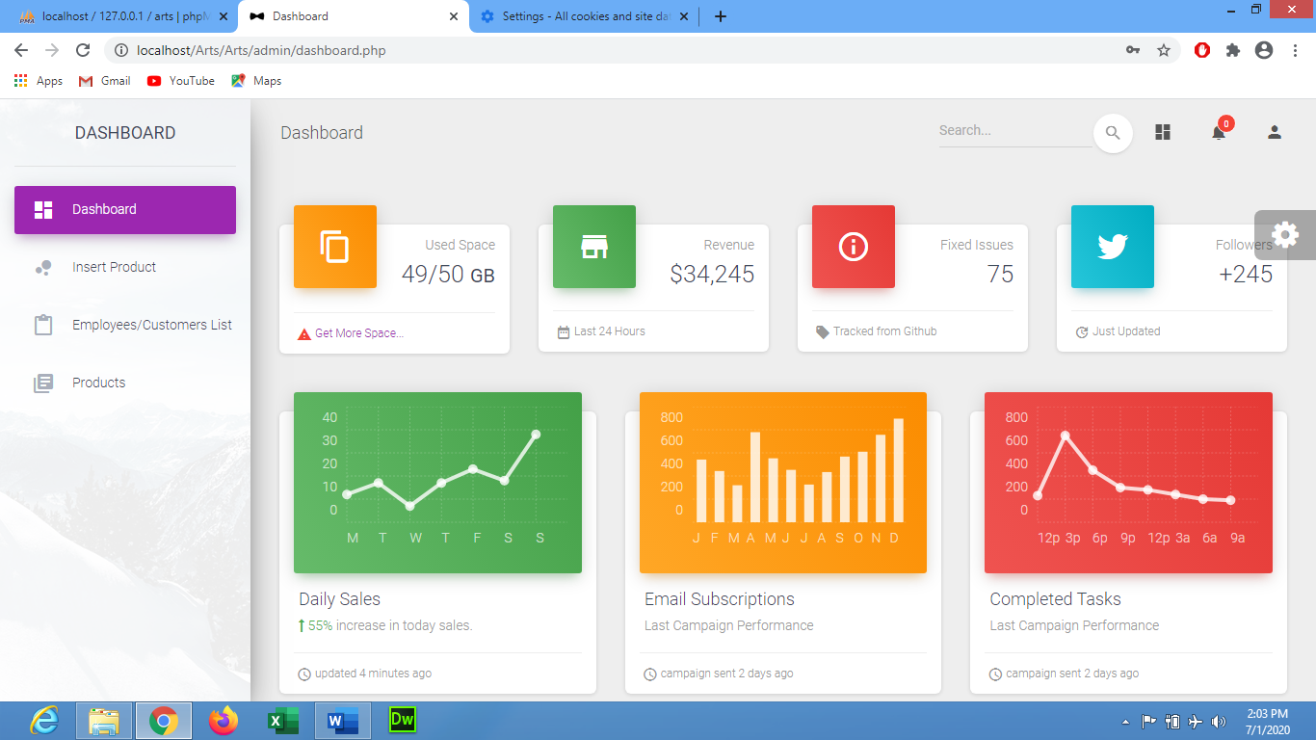

**1**

This is admin panel where different options are there, Employee/Customer Stats,Edit/View Employee/Customer stats, View/Edit Products, Insert products. These options only display in admin panel.

**Employee/Customer Stats**

**4**

**2**

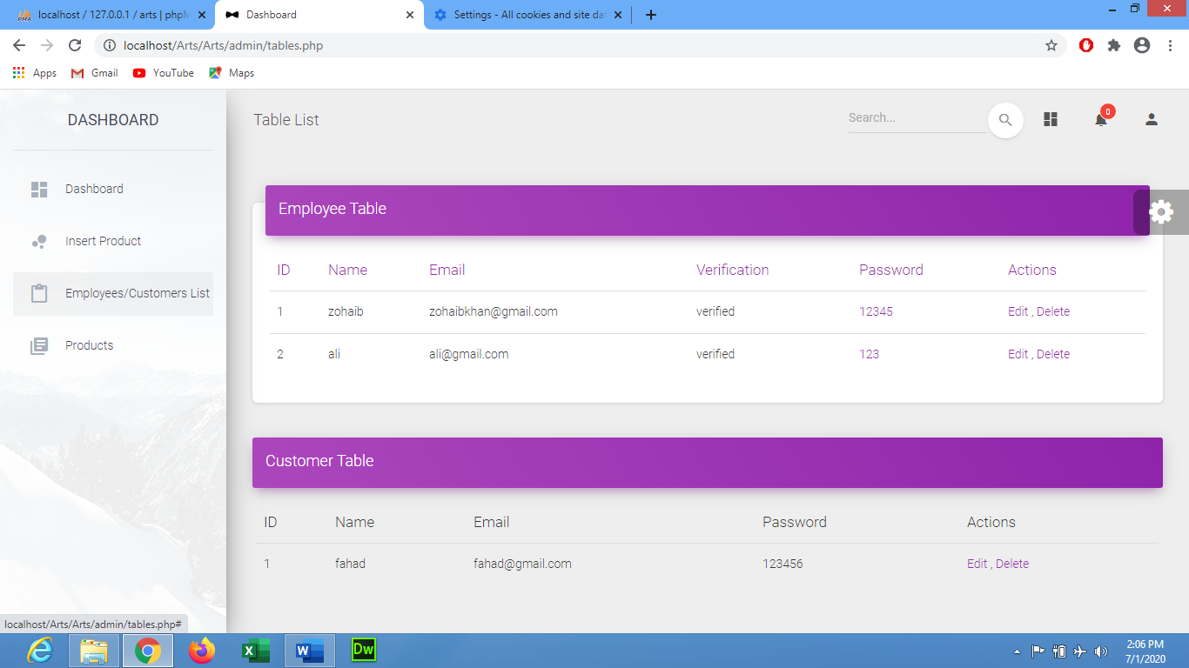

**3**

**1**

By the click of Employee/Customer Stats button a Employee/Customer Stats Details will open and by the help of Delete option you can delete any Employee who has resigned And also Customer.

**Edit/View OF Employee/Customer**

**2**

**1**

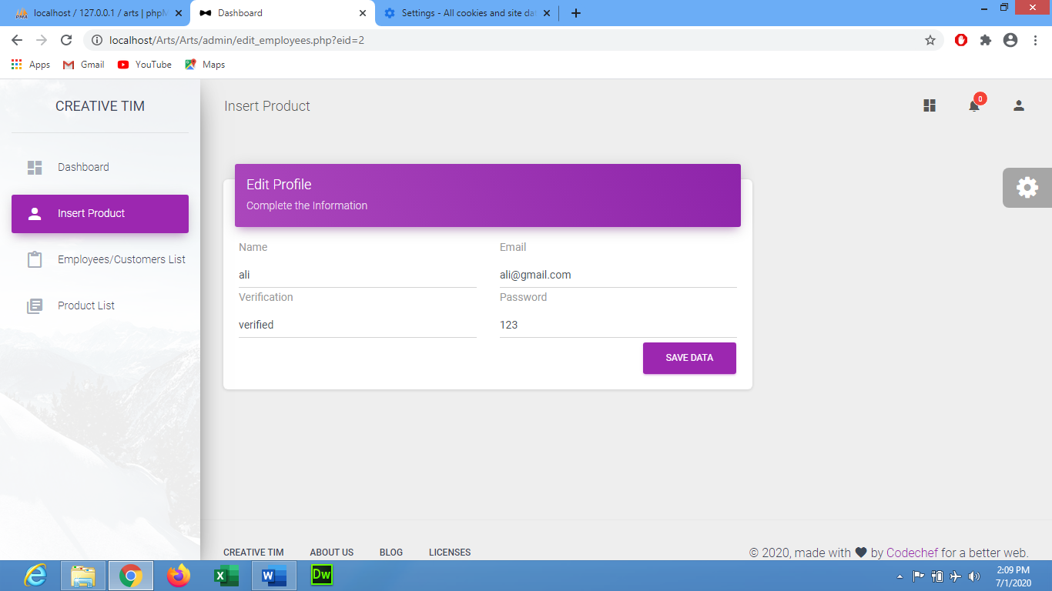

**3**

By the click of Edit/View Employee/Customer button a Employee/Customer Details will open and by the help of Delete and Edit option you can delete and edit any Data.

**Edit/View Contact Details**

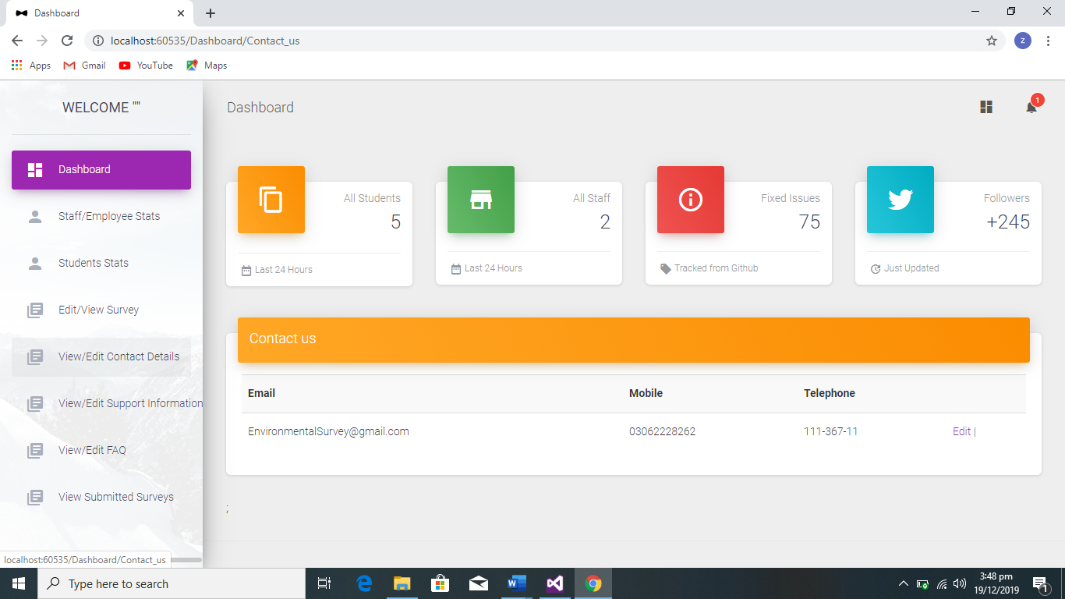

**2**

**3**

**1**

By the click of Edit/View Contact details button a Contact us Details will open and by the help of Edit option you can edit any information.

**Insert Products**

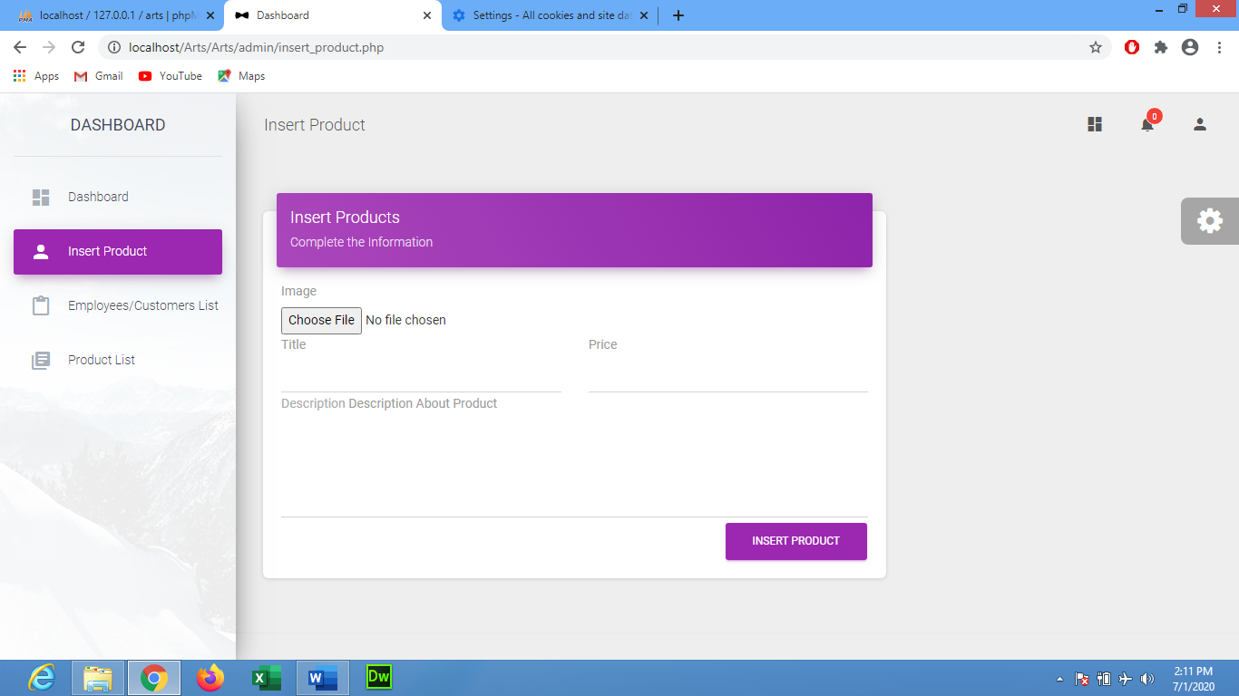

**3**

**2**

**1**

By the click of Insert Product button a Insert Products will open and by the help of Insert option you can add any Product.

**Product List**

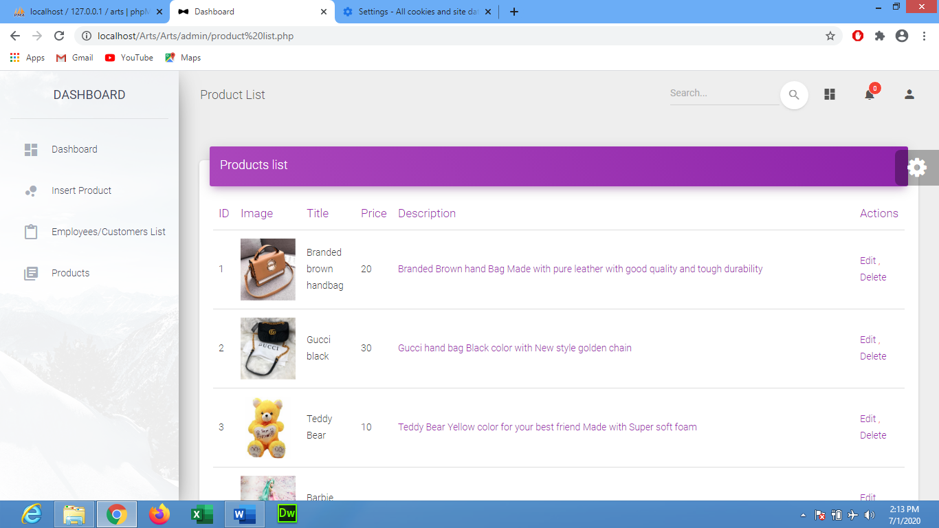

**3**

**2**

**1**

By the click of Products button a Product Details will open and by the help of Edit/Delete option you can edit/delete any information.

**View Orders**

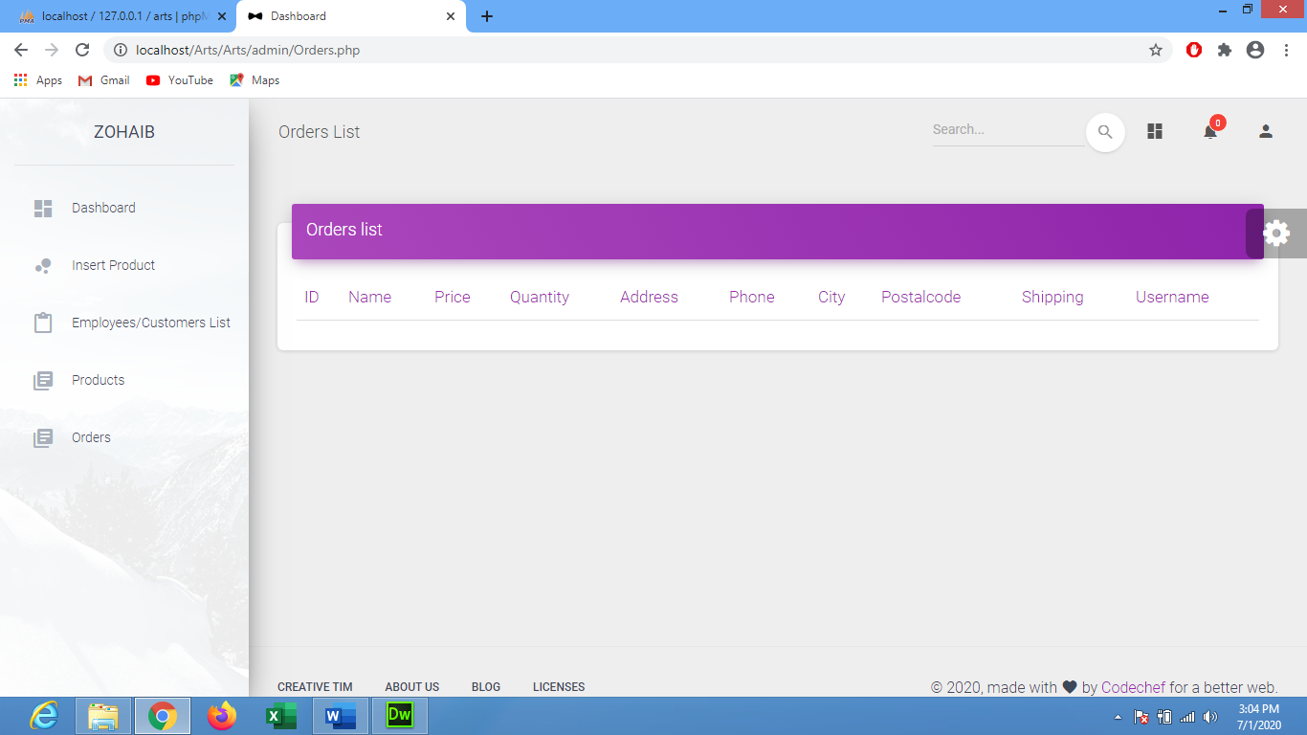

**2**

**1**

By the click of Orders button an Order Details will open.